H.T No
Regulations:
A17

Sreenidhi Institute of Science and Technology
(An Autonomous Institution)
Code No: 6A820 Date: 25-Jan-2023 (FN)

B.Tech III-Year I- Semester External Examination, January-2023 (Supplementary)
ELECTRICAL DISTRIBUTION SYSTEMS (EEE)

Time: 3 Hours Max.Marks:75
Note: a) No additional answer sheets will be provided.
b) All sub-parts of a question must be answered at one place only, otherwise it will not be valued.
c) Missing data can be assumed suitably.

Bloom's Cognitive Levels of Learning (BCLL)

Remember | L1 | Apply | L3 | Evaluate | L5
Understand | L2 | Analyze | L4 | Create | L6

Part - A Max.Marks:25

Answer all QUESTIONS.
 |  | BCLL | CO(s) | Marks
1 | Define i) Demand Factor ii) Maximum Demand | L1 | CO1 | [2M]
2 | Classify different types of primary feeders and give their merits and demerits. | L2 | CO2 | [2M]
3 | Draw the double bud double breaker bus scheme. | L1 | CO3 | [2M]
4 | Give the power loss relation between two-phase three-wire lateral with multi grounded neutral to three-phase lateral. | L2 | CO4 | [2M]
5 | List the operating modes of sectionalizer. | L1 | CO5 | [2M]
6 | Outline the need of power factor correction. | L2 | CO6 | [3M]
7 | Draw the Agricultural and Commercial Load Characteristics. | L1 | CO1 | [3M]
8 | List out the advantages and disadvantages of ring bus scheme. | L1 | CO3 | [3M]
9 | Define Capacitor unit and capacitor bank. | L1 | CO6 | [3M]
10 | Outline the operation of a circuit breaker. | L1 | CO5 | [3M]

Part – B Max.Marks:50
ANSWER ANY FIVE QUESTIONS. EACH QUESTION CARRIES 10 MARKS.

 |  |  | BCLL | CO(s) | Marks
11. | a) | Derive the relationship between load factor and loss factor. | L3 | CO1 | [5M]
 | b) | Assume that there are two primary feeders supplied by one of three transformers located at riverside distribution station as in Fig.1, one of feeder supplies industrial load between 8AM and 11PM with peak of 2000KW at 5PM, the other one feeds a residential load between 6AM and 12PM with peak of 2000KW at 9PM, determine:  - Diversity factor of the load connected to transformer T3  - Load factor of the load connected to transformer T3  - Coincidence factor of the load connected to transformer T3  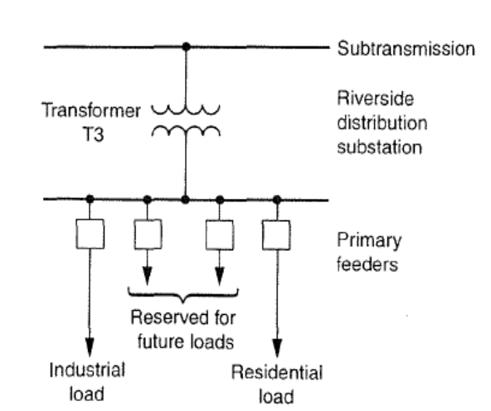 | L3 | CO1 | [5M]
12. | a) | Explain the various factors affecting the primary feeder voltage level selection process. | L2 | CO2 | [5M]
 | b) | With help of neat diagram, analyze the operation of loop type primary feeder. | L4 | CO2 | [5M]
13. | a) | Discuss the factors to be considered in selecting a location for a substation and explain the advantages of optimal location of substations. | L2 | CO3 | [5M]
 | b) | Compare Different types of bus schemes. | L3 | CO3 | [5M]
14. | a) | Derive the equations for voltage drop in Non-uniformly distribution system. | L3 | CO4 | [5M]
 | b) | A three phase express feeder has an impedance of 6+J20 Ω per phase. At the load end line to line voltages is 13.8kV and the total three phase power is 1200 kW at a lagging power factor of 0.8. by using the line-to-neutral method, determine:  - The power factor at the sending end  - The copper loss | L3 | CO4 | [5M]
15. | a) | Differentiate between a distribution circuit breaker and a distribution reclosure. Identify respective location using a diagram. | L3 | CO5 | [5M]
 | b) | Analyze the different types of faults that occurs in distribution system, explain the procedure for calculation of fault current in Line-line fault. | L4 | CO5 | [5M]
16. | a) | Which are the various benefits that can be derived from capacitor installation? Explain any two of them. | L2 | CO6 | [5M]
 | b) | Explain the different types of feeder voltage regulators. | L2 | CO6 | [5M]
17. | a) | A 120 MW substation delivers 120 MW for 4 Hrs, 60 MW for 10 Hrs and shut down for rest of each day. It is also shut down for the maintenance for 30 days each year. Calculate its annual load factor. | L3 | CO1 | [4M]
 | b) | Compare the radial and loop type primary feeders. | L3 | CO2 | [3M]
 | c) | Explain how to decide the rating of a distribution a substation? | L2 | CO3 | [3M]
18. | a) | Why voltage drop considerations are important in a distribution system. | L2 | CO4 | [4M]
 | b) | What is the need for coordination of protective devices? | L2 | CO5 | [3M]
 | c) | Describe the function of series capacitor. | L2 | CO6 | [3M]

-- 00 -- 00 –

